Instructions For Using OrbixInfo Utility

Introduction

When the users (or Wilcox testers) are having trouble using the I-DEAS DCI, the first resource to use for resolving the problem is to use the OrbixInfo utility. OrbixInfo is a small program that will test the connection to an I-DEAS server. It has settings similar to the INI file settings described in the Direct CAD Interfaces instruction file (http://www.wilcoxassoc.com/files.htm#instructional_files). The difference with OrbixInfo is that all the settings are modified from the user interface. If you can get OrbixInfo working, then PC-DMIS, with similar settings, should work as well.

Running OrbixInfo

- Copy OrbixInfoMS6A.exe, OrbixInfoMS7A, OrbixInfoMS8, or OrbixInfo9 (according to which version of I-DEAS you will be connecting to: MS6A, MS7, 8, or 9 respectively) into the same directory where the PC-DMIS executable is located, usually c:\pcdmisw. The PC-DMIS version must be 3.25 or higher. Run OrbixInfo.
- When OrbixInfo first starts, the Host and Orbix Port will be set to their defaults. The default Host is the local computer's network name. The Orbix Port is 1570. To connect to I-DEAS on a remote computer, change the Host name. The Host name must be resolvable to an IP address. In addition, the network name of the local computer must resolve to an IP address from the remote computer. Once the Host and Orbix Port are set, select the Run button.
- The first thing you should see is the Host resolved to an IP address, the ping time, and the Orbix daemon status:
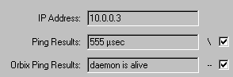

If you get an error for the Orbix Ping Results, then I-DEAS is not properly set up on the Host computer, or the specified Orbix Port is wrong.
- You can connect to I-DEAS in one of two ways. You can connect to an active I-DEAS server or you can use OrbixInfo to start up a new session of I-DEAS and connect to it. If you have difficulties connecting to a new session of I-DEAS, try connecting to an active I-DEAS server first.
  - To connect to a new session of I-DEAS, expand the Orbix Server Repository tree until you see the OpenDesign server. Select the OpenDesign server:
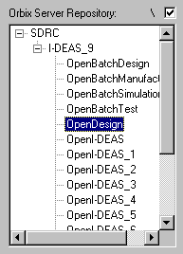

  - To connect to an active I-DEAS server, a session of I-DEAS must already be running on the Host computer. Any active I-DEAS server will be displayed in the Active Orbix Servers area. Select the server:
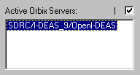

Once a server is selected from either the Orbix Server Repository or the Active Orbix Servers area, select the Connect To Selected Server button to connect. At this point, if connection to the server is successfully established, the Status Messages area should display text similar to the following:
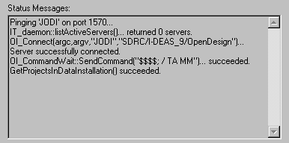

- Once connected to an I-DEAS server, you can view the contents of model files and libraries. On the right of the dialog you should see something similar to this:
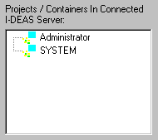

This area is showing the projects in the I-DEAS data installation. Select a project to view the model files and libraries contained in the library. Then select a model file or library to view the parts and assemblies contained in that model file/library:
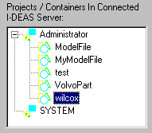

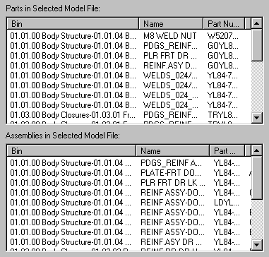

As this point, the Status Messages area should look similar to this:
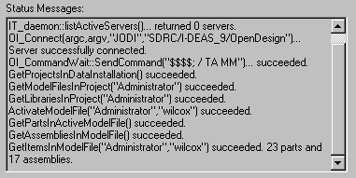

Testing FTP Connection
If the Host computer is a remote computer, you should test the FTP connection to it. The PC-DMIS I-DEAS DCI uses FTP to transfer a large file from the remote computer to the local computer. If an FTP connection is not available, importing an I-DEAS model for the first time will take a long time. For large models, many hours could be required. For this reason, it is strongly recommended to make sure an FTP connection can be established to the remote computer. The following steps describe the process:

- First, make sure an FTP server is running on the remote Host computer. You can do this by opening a command window and entering "ftp Host", where Host is the name of the computer. If the remote computer is a PC, and you don't have an FTP server for it, you can download a shareware FTP server at http://www.wftpd.com/.
- Once you've determined that an FTP server is running on the Host computer, use OrbixInfo to connect to an I-DEAS server as described in the previous section above.
- In the FTP Setup area, select the Anonymous login check-box for anonymous FTP login. You can also clear this check-box and enter a username and password for FTP login. Whichever login you choose, the PC-DMIS DCI will work better if the login user has write privileges to the I-DEAS scratch file directory (see below) on the remote Host computer:
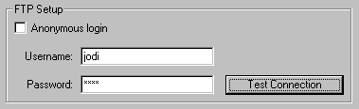

- Test the FTP connection to the remote computer by selecting the Test Connection button. In the Status Messages area, information regarding the FTP connection attempt will be displayed. If OrbixInfo is able to successfully connect to the FTP server, a test file will be written and then read from the scratch file directory. The transfer rates for this test file will be displayed in the Status Messages area.

One particularly useful message displayed will be the I-DEAS scratch directory:
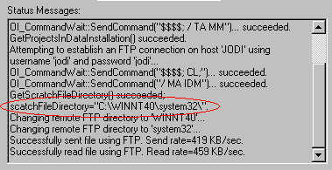

Once you know the I-DEAS scratch file directory, you can use the FTP server software to set up a user account that has read and write privileges to this directory. Use this username and password for the FTP login.

If OrbixInfo is able to connect to the FTP server and read/write to the I-DEAS scratch file directory, the PC-DMIS I-DEAS DCI will be able to import I-DEAS models at a reasonable speed.

